Data

Evidence of correct data

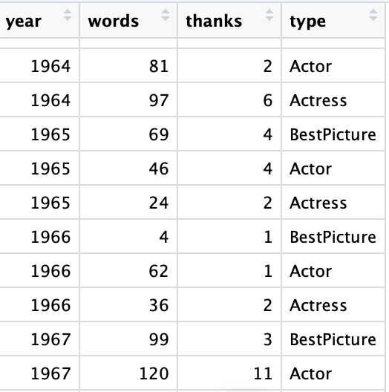

Response variable: **thanks** (the number of times the acceptance speech says ‘thanks’, Quantitative)

Explanatory variables: year (Quantitative), words (Quantitative), type (Categorical)

1. Model:

thanks ~ Poisson( exp(beta0 + beta1 year + beta2 words + beta3 Actor + beta4 Actress))

|  |  |  |
| --- | --- | --- |
| variable | Estimate | Std. Error |
| Beta0 | -25. 4579 | 3.766 |
| Beta1 | 0.0133 | 1.909e-03 |
| Beta2 | 0.00234 | 2.507e-04 |
| Beta3 | -0.1317 | 7.713e-02 |
| Beta4 | 0.0325 | 7.423e-02 |

1. Oscar winners are becoming more thankful.

For each additional year we estimate the mean # of the number of “thanks” in the speech

increases by 1.34% (95% CI: .97%, 1.73%) holding all else constant.

1. Test Ho: there is no difference between award type on ‘thankfulness’ after adjusting for other factors at α = 0.05.

I used the ANOVA test. the test statistic is 5.0786 and the p-value is 0.07892.

We fail to reject the null hypothesis. There is no difference between award type on ‘thankfulness’.